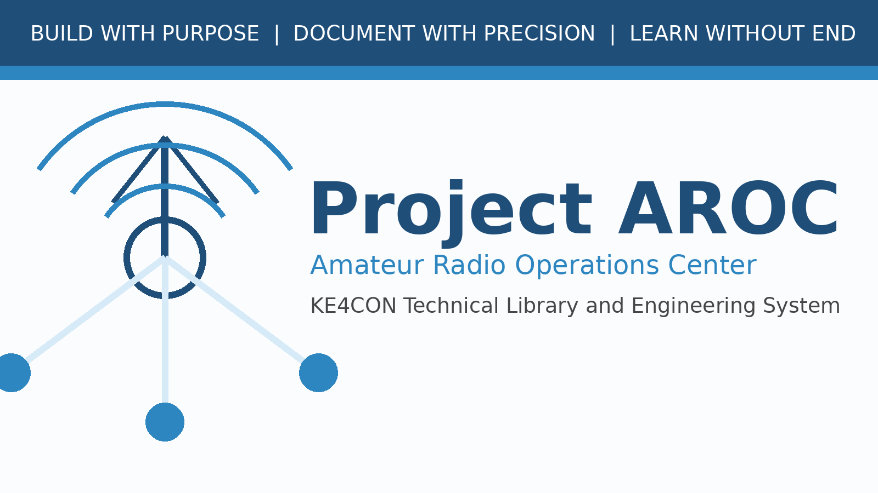

Project AROC Revision History Template
Reusable Template - Milestone 0003A

Document Number | AROC-TPL-0002
Revision | 0.1
Status | Final / Approved for Review
Project | Project AROC - KE4CON
Motto | Build with Purpose. Document with Precision. Learn without End.

Document Control
Document Number | AROC-TPL-0002
Title | Project AROC Revision History Template
Revision | 0.1
Status | Final / Approved for Review
Owner | James / KE4CON
Technical Author | ChatGPT
Applies To | Project AROC Technical Library and Engineering Documentation

Revision History
Revision | Date | Author | Description | Status
0.1 | 2026-06-30 | ChatGPT | Initial milestone 0003A publication framework draft | Final / Approved

Instructions
Copy this template when creating a new Project AROC document. Replace placeholder text with the final document number, title, revision, and content.

